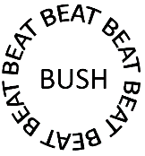
Group Name __________________ Dingbats Round
Instructions: Guess the phrase from the clues below. Write your answers in the table below. 2 POINTS PER CORRECT ANSWER
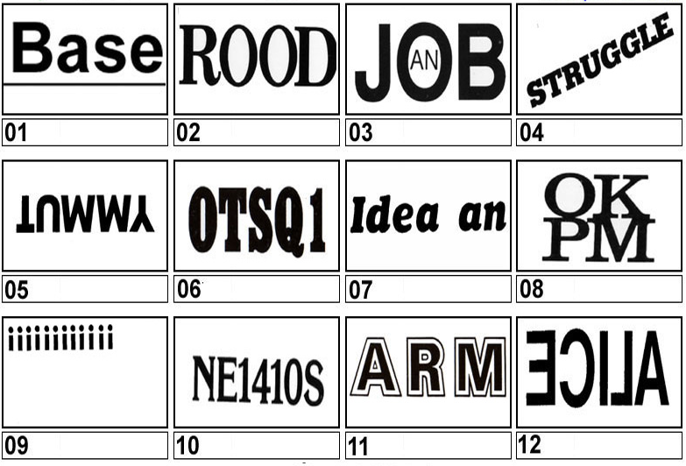
Question Number | Answers
1

2

3

4

5

6

7

8

9

10

11

12

TOTAL: /24

Dingbats Round Answers

