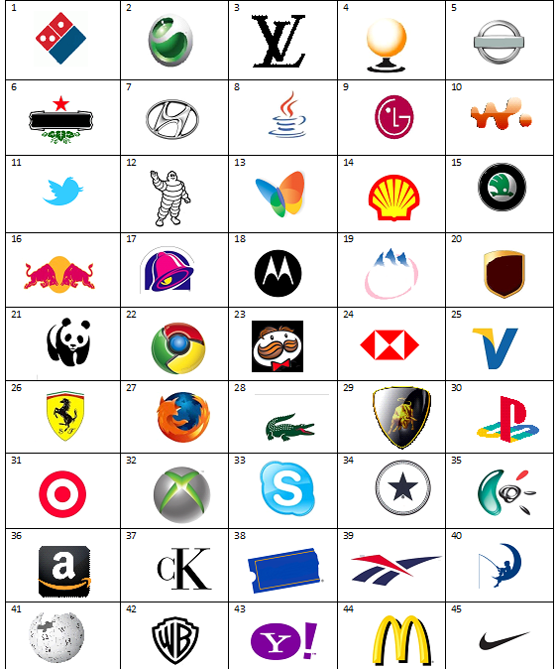
Team Name ____________________________ Guess The Brand Round
PART 1
A pretty simple round to ease you into this quiz.
INSTRUCTIONS: WRITE the names of the famous brands, legibly, IN THE TABLE provided below.
Please note: Spelling counts and there will be 10 bonus points for any team that gets 100% in this section.

1 | 8 | 15 | 22 | 29 | 36 | 43
2 | 9 | 16 | 23 | 30 | 37 | 44
3 | 10 | 17 | 24 | 31 | 38 | 45
4 | 11 | 18 | 25 | 32 | 39 | /45  + 10 BONUS  TOTAL:  /55
5 | 12 | 19 | 26 | 33 | 40
6 | 13 | 20 | 27 | 34 | 41
7 | 14 | 21 | 28 | 35 | 42
Team Name ____________________________ Guess The Brand Round
PART 2
The alphabet has been written in the image using letters from famous brands.
INSTRUCTIONS: Write the full names of the brands in the table below. Spelling counts!
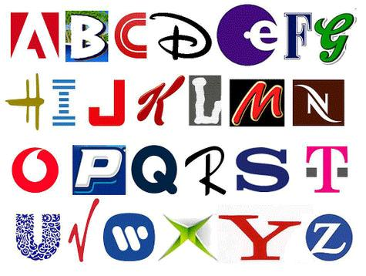

A | I | Q | Y
B | J | R | Z
C | K | S | TOTAL:  /26
D | L | T
E | M | U
F | N | V
G | O | W
H | P | X

Answers Part 1
1  Dominos | 8 Java | 15 Skoda | 22 Chrome | 29 Lamborghini | 36 Amazon | 43 Yahoo
2  Sony Ericsson | 9 LG | 16 Red Bull | 23 PRINGLES | 30 PlayStation | 37. Calvin Klein | 44 McDonalds
3  Louis Vuitton | 10 Walkman | 17 Taco Bell | 24 HSBC | 31 Target | 38 Blockbuster | 45 Nike
4  SPORCLE | 11 Twitter | 18 Motorola | 25 Visa | 32 X Box | 39 Reebok | /45  + 10 BONUS  TOTAL:  /55
5  Nissan | 12 Michelin | 19 Evian | 26 Ferrari | 33 Skype | 40 Dreamworks
6  Heineken | 13 MSN | 20 UPS | 27 Mozilla Firefox | 34 Converse | 41 Wikipedia
7  Hyundi | 14 Shell | 21 World Wildlife Fund | 28 Lacoste | 35 Dreamworks | 42 Warner Bros

Answers Part 2:
Adobe | Intel | Quizlet | Yahoo
Bounty | JVC | Rayban | Zurich
CNN | Kelloggs | Sony | TOTAL:  /26
Disney | Lee (Norwegian Clothing) | T-mobile
Etos (Drug Store – Netherlands) | Mars | Unilever
Fa | Nespresso | Virgin
Grolsch | Vodafone | Warner Music Group
Hallmark | Pepsi | Xbox

