Emojis Verb Forms – Vocabulary Builder
Activity: How many infinitive forms of verbs can you write below to represent each emoji?
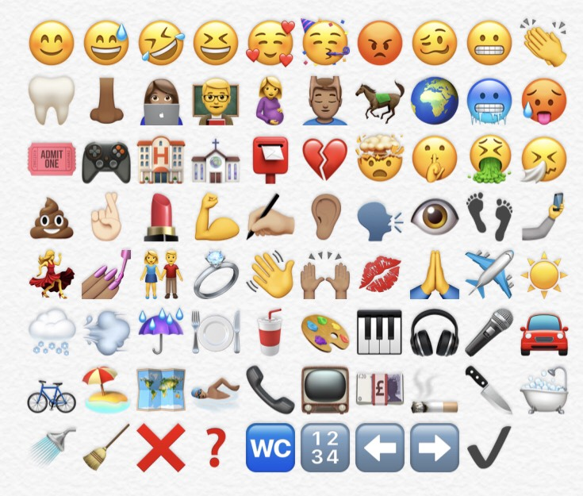
CHALLENGE:
A: Add the past participle
B: Add the he/she/it form of the verb
C. Create sentences using at least 8 of the verbs
D: Create a story on the topic of ______________________ using as many verbs as you can.

