

www.TheIdealTeacher.com



**4 WEBSITES**

**TO PRACTICE**

**VOCABULARY**





**£**

**COLOUR CODE VOCABULARY**



* **Highlight** - masculine, feminine, neuter and plural words on in different colours
* **Traffic Lights** – red (no idea how to spell), yellow (not 100% sure), green (100% sure)

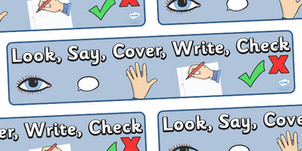

**Combine with a super quick seven column**

L, S, C, W, C **learning grid for more intense practice**

Write in English on one side and

the foreign language on the other side

MAKE FLASHCARDS

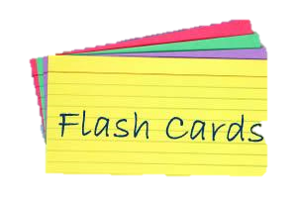

test yourself *and* get someone else to test your spelling

word

THE PYRAMID METHOD

w

**Write the word in**

**full at the top and then re-write the**

**word starting with the first letter, forming a pyramid**

wor

wo

word

MISSING VOWELS

Take a list of topic vocabulary and re-write

removing vowels. Swap with a partner and complete!

Swap back for the work to be marked



m _ s s _ n g v _ w _ ls

Categorise your words and give each category a different

colour (i.e. blue = masculine, yellow = feminine etc)

Then, write the words in the categories as a picture,

like Marge Simpson…

GET VISUAL