I-SPY PROMPTS VOCABULARY, SPEAKING & WRITING ACTIVITIES
Food & Drink

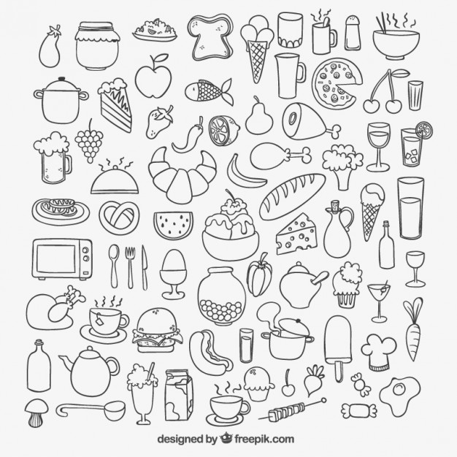
- VOCABULARY: Annotate the paper with all related words in target language
- WRITING: Choose 5-10 words and make a short story about food & drink in written form, aim for your target grade
- SPEAKING: In pairs or small groups, choose a word from the images (keep it a secret), the others have to guess the item by describing it, i.e. is it cold, is it colourful, can you eat it in summer etc.? Get a point for each one you guess correctly

