TAKE YOUR PICK PROMPTS / FRUIT
SPONTANEOUS VOCAB, SPEAKING & WRITING ACTIVITIES
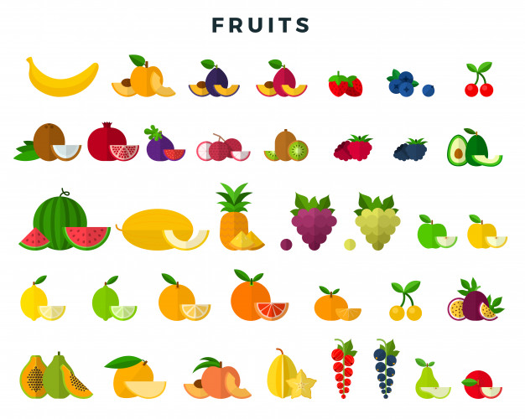

TAKE YOUR PICK:
- VOCABULARY: Annotate the paper with all related words in target language. EXTENSION – what others can you add?
- WRITING: Choose 5-10 words and make a short story about ‘FRUIT’ in written form, aim for your target grade
- SPEAKING: In pairs or small groups, choose a word from the images (keep it a secret), the others have to guess the item/verb by describing it, i.e. is it orange? Is it round etc.? Get a point for each one you guess correctly

