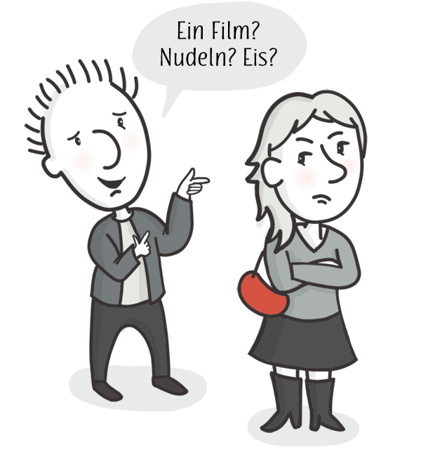
ÜBUNG 1: German Cognates

Translate the words into English
AUF DEUTSCH | IN ENGLISH
Englisch | English
Engel | angel
Banane | banana
Bär | bear
Bier | beer
Katze | cat
Schokolade | chocolate
Kaffee | coffee
Sonne | sun
Diamant | diamond
Elefant | elephant
rund | round
Feuer | fire
kühl | cool

ÜBUNG 2: Spelling

Use the key below to decipher the following German words - what do they mean in English? Try saying them out loud as you go along

Deutsch | t | tt | ss | pf | g | ff | b | ch | f | d
English | d | th | t | p | y | p | f | k | p | th

gut
Tag
trinken
Apfel
Pfeffer
sagen
Erde
Buch
hungrig
Bruder
halb
rot
Nagel
danke!
denken
besser
tanzen
Brot
laut
reiten
helfen
Leder
heiss
sprechen
Affe
Dieb
essen
Pfanne
Mutter
Bad
Wetter
Wasser
scharf

ÜBUNG 3: Writing

TEIL A:
1. Start your sentence with 'ich' (which means 'I').
2. Add the second word from the previous sheet and take off the 'n' at the end (tanzen > tanze)
3. If necessary, complete the sentence with the final word
I dance
I think
I drink beer
I speak English
I eat bread
I hate chocolate
I say 'thanks'!

TEIL B:
- Use the table to find the gender of the noun.
- Add 'ist' (which means 'is')
- Complete the sentence, i.e. The apple is red - der Apfel ist rot
The sun is hot
The mother is good
The elephant is hungry
The thief is hungry
The weather is good
The weather is cool
The brother is loud
The pan is hot
The earth is round
The nail is sharp

